|  |  |  |  |  |
| --- | --- | --- | --- | --- |
|  |  | | | |
|  | |  | | |
| Project: | | Personal Tutoring System (PTS) | | |
| Team No.: | | 12 | | |
| Class: | | CSE 3310; Fall 2023 | | |
| Module: | | Unified Modeling Language (UML) | | |
| Deliverable: | | UML Document – Increment I delivery | | |
| Version: | | [1.0] | Date: | [10/5/2023] |

Contributors:

Abner Koffi

Balaputradewa Ratuwina

Nicholas Doerfler

Om Patil

Yuko Aoki

Revision History

| Version number | Date | Originator | Reason for change | High level description of changes |
| --- | --- | --- | --- | --- |
| 1.0 | 10/5/2023 | Team# | Initial draft |  |
|  |  |  |  |  |
|  |  |  |  |  |
|  |  |  |  |  |

TABLE OF CONTENTS

1. Introduction and Project Overview 3

2. Project Context Diagram 4

3. UML Diagram 5

3.1 UML Diagram: “System” 5

3.2 UML Diagram: “Registration and Login” 6

3.3 UML Diagram: “Payments” 7

3.4 UML Diagram: “Tutoring categories” 8

3.5 UML Diagram: “Become a Tutor” 8

3.6 UML Diagram: “Hire a Tutor” 10

3.7 UML Diagram: “Search” 11

3.8 UML Diagram: “Review” 11

3.9 UML Diagram: “App Monitoring” 13

3.10 UML Diagram: “Communication” 14

3.11 UML Diagram: “Advertisement” 15

# 1. Introduction and Project Overview

The PTS (Private Tutoring Service) application will be developed for Android. The app connects tutors and students. It provides tutors a convenient way to find potential students and vice versa. The user can choose to be either tutor or as student or both at the same time. The tutors can select a category that they want to teach in. They have the option to pay to advertise themselves within the app. The students can search for the category that they are interested to learn, with an option to filter the search by location, price, and by tutor's rating, etc. The students have the option to make a review of the tutor using stars and comment once the service contract is complete. The app will make a profit of 20% for every transaction made between the tutors and the students.

# 2. Project Context Diagram

# 3. UML Diagram

## 3.1 UML Diagram: “System”

## 

## 3.2 UML Diagram: “Registration and Login”

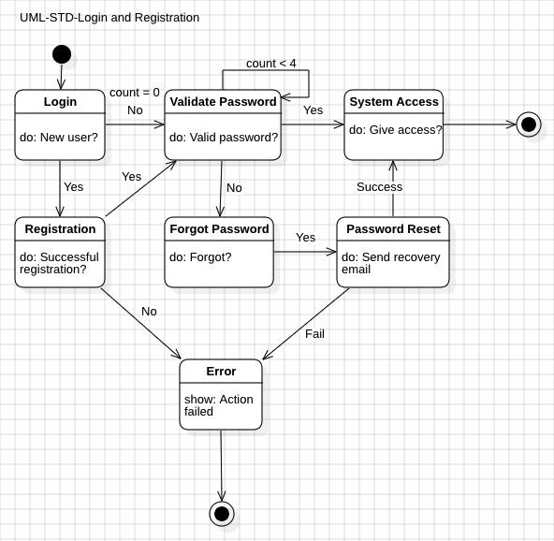

## 

## 3.3 UML Diagram: “Payments”

## 3.4 UML Diagram: “Tutoring categories”

## 3.5 UML Diagram: “Become a Tutor”

## 3.6 UML Diagram: “Hire a Tutor”

## 3.7 UML Diagram: “Search”

## 3.8 UML Diagram: “Review”

## 3.9 UML Diagram: “App Monitoring”

## 3.10 UML Diagram: “Communication”

## 3.11 UML Diagram: “Advertisement”

